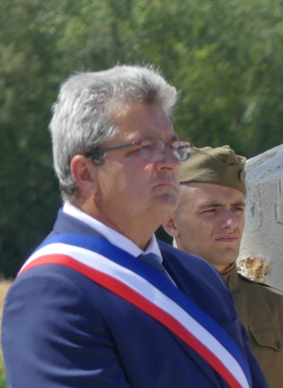 | Discours Didier Fernadez  Maire de Seringes-et-Nesles  Mémorial de la Ferme de la Croix Rouge – 28 juillet 2018

Monsieur le Préfet, Monsieur le représentant de l'Ambassade des Etats Unis, Monsieur le représentant de l'Ambassade D'Allemagne, Monsieur le Député, Monsieur le Sénateur, Monsieur le Président du conseil départementale, Mesdames et Messieurs les officiers généraux et supérieurs, Mesdames et Messieurs les conseillers régionaux, Mesdames et Messieurs les conseillers départementaux, Monsieur le Président de la communauté d'agglomération de Château Thierry, Mesdames et Messieurs les Maires, Mesdames et Messieurs les élus, Mesdames et Messieurs les représentants des anciens combattants, Mesdames et Messieurs chers amis.

Seringes and Nesle, small village of 290 inhabitants, with its street named after corporal Watkins, its Memorial Day street, its way of the 42nd, and especially the Meurcy Farm, which like the Croix Rouge Farm in Fere en Tardenois, marked the history of our village.

Seringes and Nesles for decades through these different mayors has always proudly paid, on our national holidays, on Memorial Day, the deserved tribute to these men. In Seringes, daily, we live with the history of these fighters, these fighters who made the ultimate sacrifice.

On May 27, 2001, Mayor Jacques Damery, paid a special tribute to this magnificent division for which we are gathered this afternoon, by having a commemorative plaque placed at Meurcy Farm, a plaque to honor the memory of the historical facts of this great and beautiful Rainbow Division, This plaque was moved here in 2014, you can see it today on this site watched as it should be, by our beautiful bronze soldier. This plaque was a source of pride for Mr Damery and that is why, in paying tribute to these men, I also wanted to pay tribute to him.

On this day of May 2001, in his speech, he would speak about memory and respect for all these soldiers, the fact that it was in our community of Seringes that the 42nd endured the worst sufferings. The points of resistance to be destroyed were Green Mill, Colas Wood, hills 178 and 202, Meurcy farm, these positions taken and lost several times were strewn with deaths, speaking of these men he will say that they were too brave to abandon the terrain, he will also say that the image of the rainbow spanning the horizons, was the mystical symbol, deployed in the heavens, to signal the passage of a storm and the birth of a new hope for humanity

Today, also on this day of commemoration, we too would have liked to see a beautiful rainbow shine, which for us would have been a beautiful symbol. May the image of the rainbow tell us never to forget, never to forget those fighters who by their bravery made us free men, so today, with our American brothers, let us commemorate, tomorrow with our American brothers, with our German brothers, let us celebrate peace together, for all of us present here on this beautiful day of thanks, may the rainbow remain engraved in our memories as the symbol of peace in homage to this division and symbol of diversity in the world for these colors, let us be the passers of history. Time must not erase the memory

