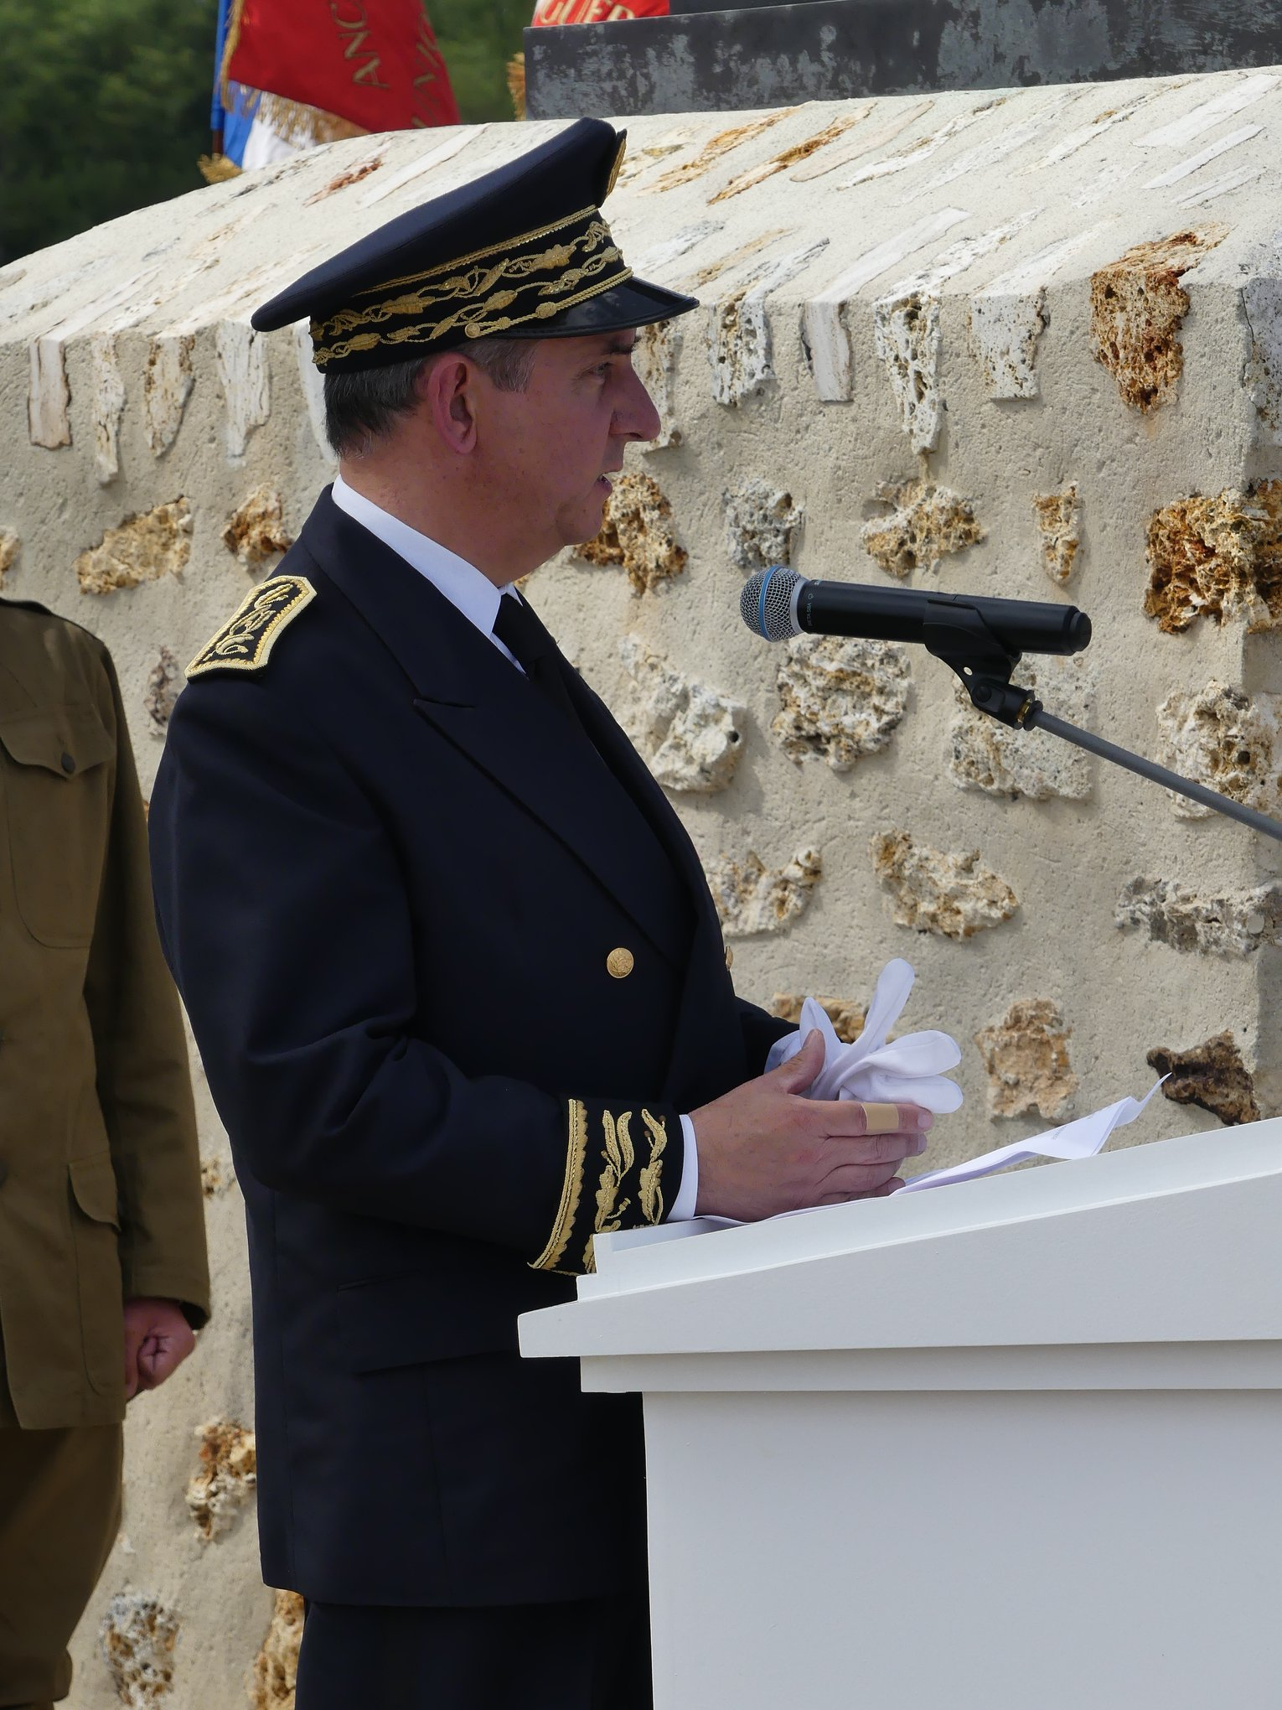 | Discours Nicolas Basselier  Préfet de l’Aisne  Mémorial de la Ferme de la Croix Rouge – 28 juillet 2018

Representative, Senator, President of the Departmental Council, Mayors, Elected Officials, Generals, Representative of the German Embassy, Madam President of the Croix Rouge Farm Memorial Foundation, Ladies and Gentlemen Flag Bearers, Ladies and Gentlemen,

Who remembers today the great battle that took place on the plateaux of Soissonnais and Tardenois, a hundred years ago?

And yet, it is there that a turning point in the Great War took place.

In the spring of 1918, when the belligerents had been buried in the trenches for more than three years and all attempts to break the front had failed, the German General Staff played their all-out game in the Aisne.
On May 27, 1918, German assault troops broke through the Chemin des Dames, jostled French troops and entered Château-Thierry on June 1, directly threatening Paris. The second battle of the Marne had started, which allowed the French Poilus, supported by their Allies, to stop the advance of the Imperial Army, then launch an impetuous counteroffensive on July 18th.

The young army of the United States of America, which had started arriving in France in June 1917, would take a decisive part in these fights, which will lead less than four months later to victory.
Formed in August 1917, the 42nd Infantry Division pulled together soldiers from 26 states, earning its nickname of "Rainbow" Division.

On July 26, 1918, the 167th Alabama Regiment and the 168th Iowa Regiment stormed the Croix Rouge Farm, heavily defended by the enemy. Without any artillery preparation, the attack was carried out in the open. After ferocious clashes, often in hand-to-hand combat, the position was carried away. On July 28, the Ourcq was crossed and the German troops were pushed back nearly 20 km.

General MacArthur would underline the extreme bravery shown by the soldiers of the 42nd Division at the cost of heavy losses, nearly 6,500 men, including 1,410 killed.

With those of the Meuse, it is on the battlefields of the Aisne that the American army knew the deadliest combats, as the cemeteries of Belleau and Seringes-et-Nesles remind us, as well as this poignant memorial inaugurated at the very site of the Croix Rouge Farm in November 2011.

Of the 2 million men who landed in France, 116,000 made the sacrifice of their lives on our soil in the space of six months. It is more than during the three years of war in Korea or the nine years of war in Vietnam.
If the Great War is too often in the United States the "forgotten war", the large public around us today is there to say that this is absolutely not the case in France.
Our country knows what it owes to all those who fought alongside her in defense of freedom and democracy. A century later, she is always keen to celebrate their heroism and honor their memory.

For four years now, the centenary of the Great War has been mobilizing a great many actors, State, local authorities, associations and citizens, to whom I renew the expression of my deep gratitude for their remarkable commitment.

These commemorations allow us to testify of our loyalty and our gratitude to the American soldiers who died on the field of honor for the liberation of our country.

They are also a strong reminder of the unwavering ties that unite our two countries!

