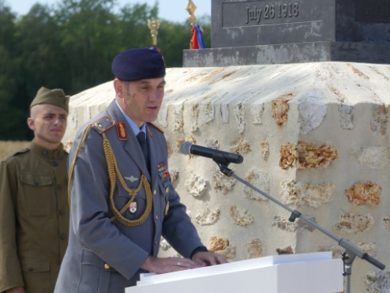 | Général de brigade  Werner Albl,  representative of the German Embassy  Mémorial de la Ferme de la Croix Rouge – 28 juillet 2018

Every war is a tragedy. Our common memory is an opportunity!

We are gathered here today in a region steeped in history to commemorate the centennial of the Battle of the Croix Rouge Farm at the 42nd Rainbow Division Memorial.
And also to remember together the dark pages of our history and pay tribute to the soldiers who gave their lives in this fierce battle 100 years ago.

Nor do we forget the families to whom this war has caused infinite grief and who have lost forever a husband, father, brother, son or friend. Only one generation after the Great War, young people would die again on the battlefields where their fathers had already fought. The German military cemetery at Fort de Malmaison, some 30 kilometers from here, bears witness to this and reminds us that such horrors should never happen again. We bow our head before the memory of these men as well and before all those who suffered with them.

Today, a century after the fighting of the Ourcq, the dead have no uniform, no religion. We no longer differentiate between nationalities, origins or places. We commemorate those who have fallen without distinction.

We, French, Americans and Germans, once enemies on the battlefields, now stand together. We are moving side by side towards a future in which war has no place. We know and respect each other, we are friends. We do a work of common memory like today at the Croix Rouge Farm Memorial. This shared culture of memory enables us also to find resources to accomplish our tasks for a common future, for the good of our peoples, our countries and the whole world.

But every day we can see and feel around us the fragility of peace. To remind us of this, all we have to do is meet the soldiers of Operation Sentinel who are a bulwark against terrorism here in France and think of the French, American and German soldiers deployed side by side with allies to defend our security in Afghanistan, Iraq or in the Sahel.

Preserving peace on the basis of our common democratic values is an objective for our nations and the basis for the prosperity of Europe and the world.

On the basis of our friendship, we are deepening the partnerships we have forged in Europe and within the Atlantic Alliance. We have many strong ties. I am thinking not only of political cooperation, but also of the friendship experienced on a daily basis.

I am very honored to be with you today at this ceremony, which is being held in the presence of French and American troops to commemorate this centennial. It is in doing such actions and during such moments when we think of those who fought that the word "peace" gets its full meaning.

I also feel an immense gratitude when I see that we can be together today to remember together the dark hours of our history and to draw from them the energy to walk together towards a future of peace.

For war cannot happen when peoples are friends.

Thank you for your attention.

