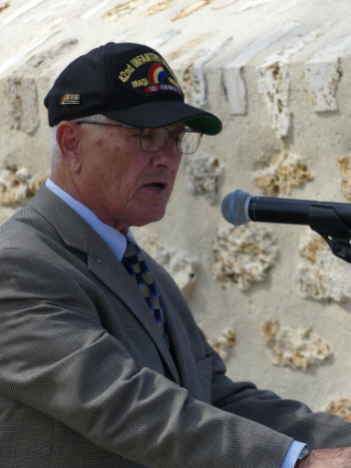 | Discours du General Joseph Taluto, Président de l’Association  des Vétérans de la 42e Division,  la Division Arc-en-Ciel  Mémorial de la Ferme de la Croix Rouge – 28 juillet 2018

Acknowledgement of dignitaries.

I am honored to represent the rainbow division veterans foundation.

Our foundation’s mission is to commemorate the deeds, sacrifices and traditions of the 42nd infantry division through memorials, education and preserving the legacy of the 42nd division.

Ceremonies such as the one today at the oise-aisne cemetery and memorials like this one at the croix rouge farm reinforces the importance of our need to take time to contemplate the price that has been paid to protect freedom. when we see these final resting places and memorials to our fallen heroes we must never forget the sacrifice it takes to maintain our liberties and way of life

As we celebrate the achievement of our alliance to defend freedom during wwi we are also reminded that our countries have a proven history of defending and protecting freedom through the years. our friendship and alliance has proven that together we are stronger in maintaining peace

On behalf of the rainbow division veterans foundation i would like to thank our gracious french hosts for their hospitality and this wonderful ceremony.

In particular i would like to thank commissioner monique seefried a true friend of the rainbow division for her long and faithful service to the foundation and for her help not only today but through the years.

