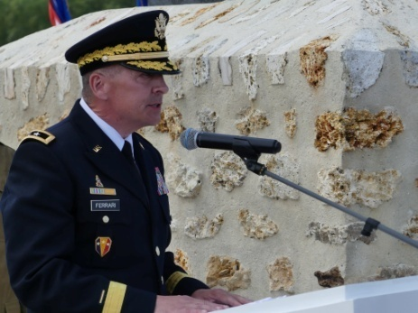 | Discours du General StevenFerrari, Commandant de la 42e Division, la Division Arc-en-Ciel  Mémorial de la Ferme de la Croix Rouge – 28 juillet 2018

Distinguished french and amercian guests, general officers, ladies and gentlemen, it’s an honor to be here today representing the famous 42nd infantry division as the commanding general during our 100th anniversary and world war i commemoration events.

the 42nd infantry division was formed in august 1917 when it was organized with 27,000 national guard members from 26 different states and then activated for service in ww i at camp mills, long island, new york. there were four primary infantry regiments; the 165th from new york, the 166th from ohio, the 167th from alabama and the 168th from iowa. col douglas macarthur then the division chief of staff commented that “the 42nd division stretched like a rainbow from one end of america to the other” and the rainbow division was named.

the division proudly served in the great war with the allied forces and took part in four major operations. the one we recognize today the aisne-marne campaign and croix rouge farm took place during the second battle for marne beginning on 26 july 1918 as part of the american i corps and french 6th army. brigadier general MacArthur was quoted as saying the battle at the croix rouge farm was one of the few occasions in which the bayonet was decisively used. the divison fought for nine days here and lost over 5000 soldiers.
the 42nd has a long and historic lineage and we are all proud to wear the rainbow patch. the unit is only the symbol and bond for the people who serve or have served. so we must never forget the soldiers of our division and the allied forces that fought for freedom 100 years ago.

to the soldiers of the 42nd id and our allies, past, present and future, thank you for your indomitable fighting spirit and like the generations of service members before us, we will continue to demonstrate that our nations remain the world’s brightest beacon of hope for freedom and peace.
we must never forget our historic 100 year lineage and our partnerships. it’s our responsibility to ensure we continue our countries proud and decorated heritages.
we want to pay a special tribute to monique seefried for her efforts to ensure the 42ndinfantry division monument was able to be placed here at the croix rouge farm. we are forever grateful. merci beacoup monique
thank you to france for hosting the 42nd infantry division on these hollowed grounds. rainbow “never forget”

